Biology-1
Rod Deluhery
Date March 31, 2026

Using the observation approach to science, my goal was to observe live eukaryotic cells using a microscope.
I used one (1) drop of saline water, approximately .05 ml, mixed with approximately .01 ml blood from my finger. I did not have a transfer pipette, so I used this disposable eye drop container to place .01 ml of fingertip blood into a bubble of saline water, then applied the blood/saline drop on to my microscope slide. The blood to saline ratio was approximately 20% blood to 80% saline. Actual observations in the microscope showed the blood mixture was not uniform, as I had not properly mixed the two solutions.

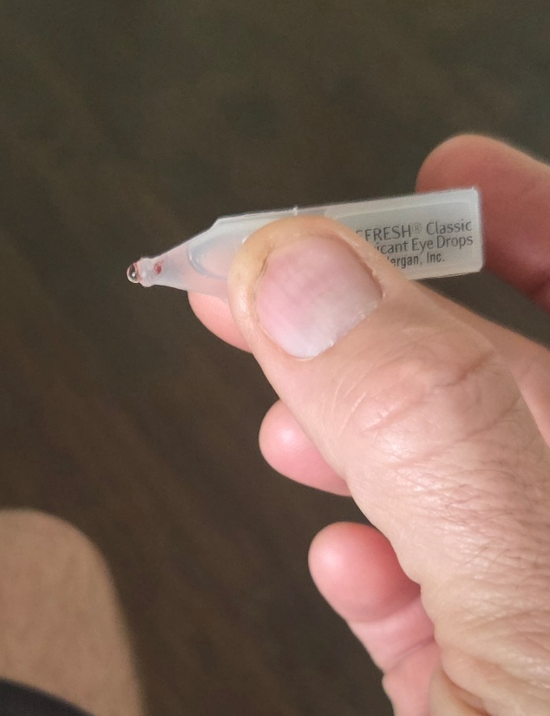
Figure 1 Pipette used for mixing solution
I repeated this experiment three (3) times, cleaning the microscope lens each time, as I had to contact the microscope lens directly in the specimen drop, see figure 2. I did not have cover slips for my microscope, and using this technique I learned that it is possible to view specimens this way. For me, this was a new technique, and it worked well. At 400x and 1000x, using the 40x and 100x objective lens, the lens is immersed in the solution, and items will move in the solution, making tracking objects a bit challenging. The practice is not normal, yet I was pleased with the views done using this method, without a cover slip. I also did not have a concave microscope slide for this.
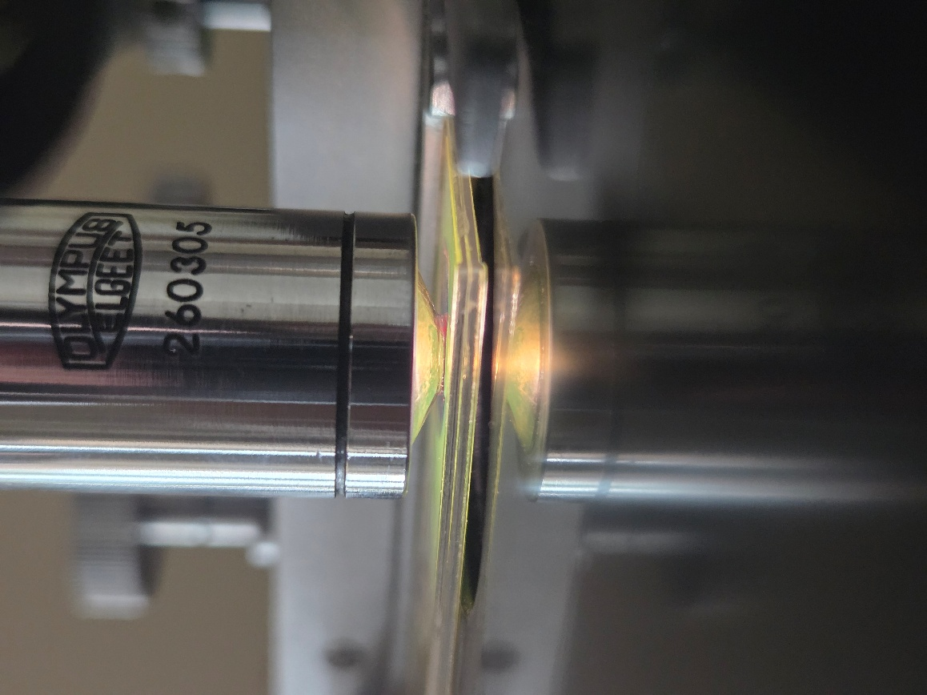
Figure 2
The results of my observations was that blood can be viewed under a light microscope, in solution, at 40x, 100x, 400x and 1000x as long as the solution is diluted. In a previous year I had tried to view blood directly and I knew that it does not work without being diluted. I learned that I needed to lower the light level in order to view these well. I learned that blood will coagulate within 10-30 minutes even in a solution of water (see figure 5). In figure 5, the blood and particles were visible on the slide, the cells had formed blobs, viewable with the naked eye (not using the microscope). In figure 5 large amounts of blood are connected to form large blobs of blood. I also noticed blood start to coagulate very quickly within seconds of being outside the body, and I hypothesized that the strange 3D shapes of the blood was that coagulation process starting.
I learned that blood cells will connect to each other in odd 3D shapes to form complex designs, some of which the details could I could see in the microscope by adjusting the focus (depth of field). See figure 3.
I found cells that appeared with spikes, and I do not know what these were. In research I found that often white blood cells are generally larger than red blood cells. In looking at other photos of white blood cells, these mystery objects do resemble white blood cells. My only challenge was that they appeared usually the same size or smaller than the more common red blood cells. The information on the internet may not apply to this fingertip blood specimen? My hypothesis is that fingertip blood may be different than blood pulled from a vein, using syringe or needle.
The items with spikes, Figure 4 shows them at 1000x, the spikes are difficult to see, the pointer in the microscope is near one of the spiked objects. In photo labeled figure 6, please note in the upper left hand corner, I notated in red drawing, three (3) of these spiked cells appear. I noticed sometimes these were attached to other blood cells, perhaps they were blood cells in some sort of transition?
The photo in figure 7 is the Olympus microscope used for this work, it is an older model. I have noticed the image quality is somewhat less than the microscopes at school (Nikon). The image quality is very similar in many of the settings. For the photos, I held my phone camera to the ocular lens. I used a Samsung phone using the 3x setting to take photos of the microscopic images.

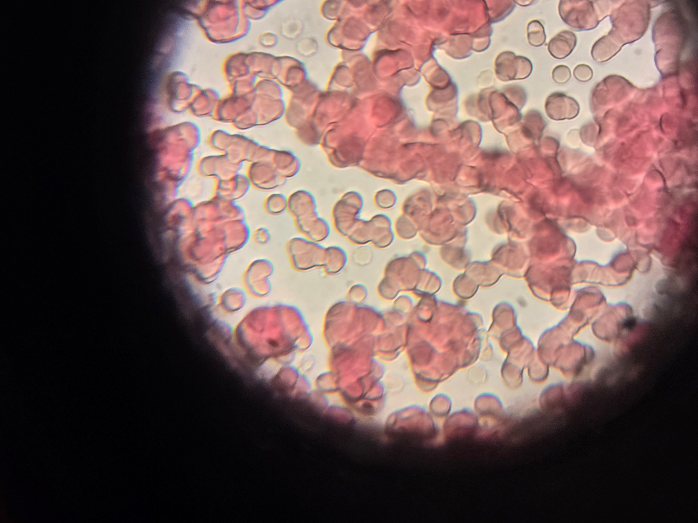
Figure 3
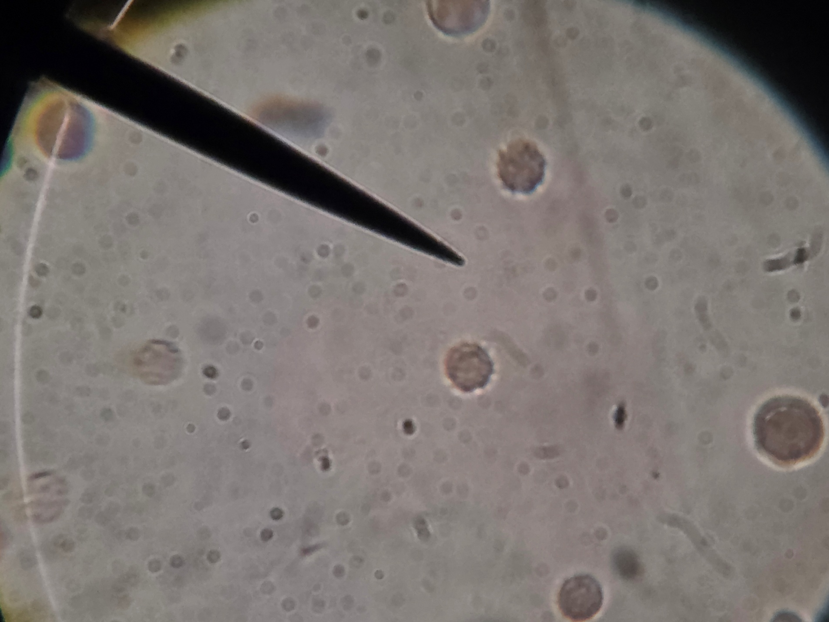
Figure 4
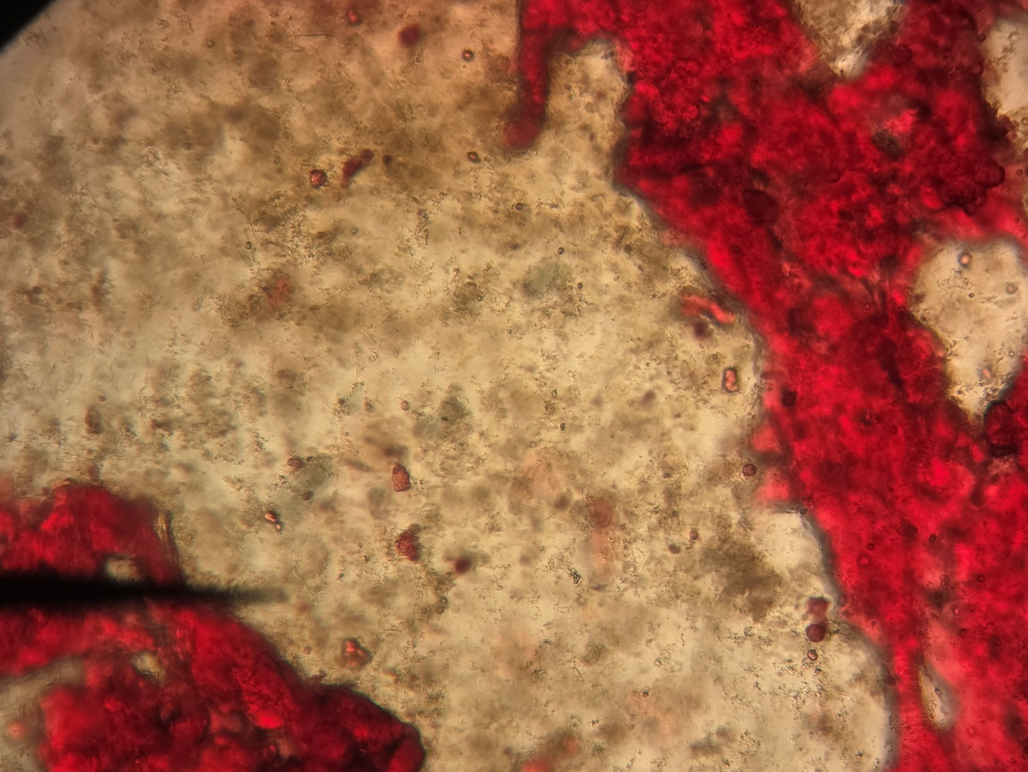
Figure 5
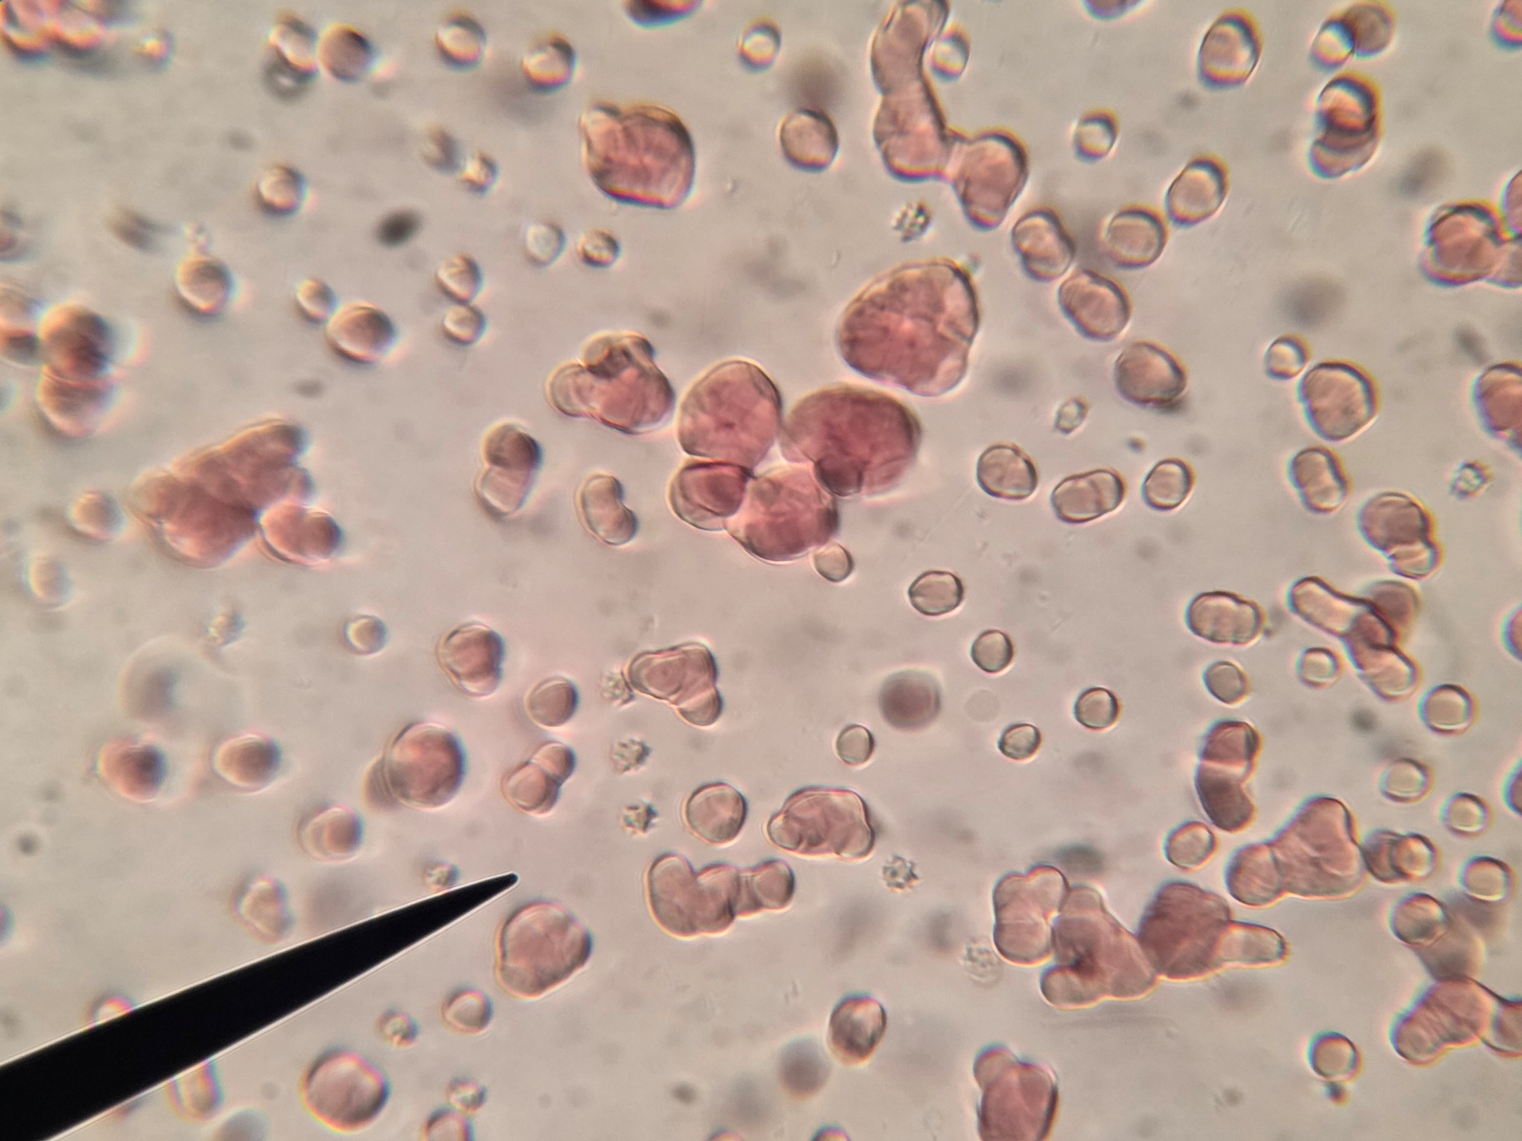
Figure 6
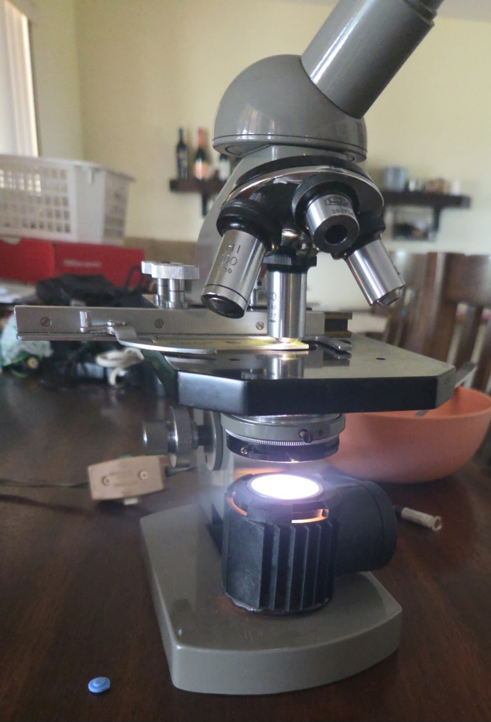
Figure 7

